**PENN STATE**

*Justice Center for Research*

Derek Kreager, Director

Gary Zajac, Managing Director

*Message from the Director*

Hello from a cool central PA! We had a productive fall

semester capped by a successful board meeting. We’re

now looking forward to capturing momentum and

accomplishing as much as possible this spring. We are

particularly focused on outreach to our agency partners

and criminal justice alumni, as well as creating student enrichment opportunities. Consistent with our new center themes, our newsletter now covers developments in the areas of courts and sentencing, corrections and re-entry, substance abuse and treatment, and policy and evaluation. We hope this more easily directs you to specific areas of interest. We also chose to support new seed grants that cover all of our themes and look forward to supporting this research moving forward. Congratulations, awardees! We are particularly interested in supporting research in the area of substance abuse and treatment, given the work of several center investigators and opioid initiatives at the college, institute, and university levels.

*Dr. Derek Kreager*

*Dr. Gary Zajac*

The Docket January 2018

**The Justice Center for Research is a Partnership of the College of the Liberal Arts and University Outreach**

***COURTS AND SENTENCING***

# The Administration of the Death Penalty in Pennsylvania Project Report Released

The Justice Center for Research recently released a much anticipated report on disparity in death sentencing in Pennsylvania.  The report - Capital Punishment in Pennsylvania: 2000-2010 Implications for Racial, Ethnic and Other Disparities - was led by Justice Center affiliates Professor Emeritus John Kramer, Professor Jeffery Ulmer, both of the Department of Sociology & Criminology and Dr. Gary Zajac, Center Managing Director. Numerous Justice Center Researchers and Graduate Students also contributed to this project over the years.  This study had been commissioned by the Pennsylvania Interbranch Commission for Gender, Racial and Ethnic Fairness, and was funded by them and by the Falk Foundation.  While this study found no significant disparity to the disadvantage of black defendants overall, it did find race-of-victim effects, where defendants who murdered a white victim were more likely to receive a capital sentence than were defendants who murdered a non-white victim, regardless of the race of the defendant.  The race-of-victim effects are very commonly found in studies of this sort.  This study also found some differences in case outcomes associated with type of defense counsel, and found considerable geographic (county-based) differences in case outcomes.  This report also contributes to the work on capital sentencing in Pennsylvania currently being undertaken under the auspices of PA Senate Resolution 6 of 2011.  The full report can be found on the Justice Center website at: <http://justicecenter.la.psu.edu/research/active-funded-research-projects-2>

Presentation by Seth Miller, Executive Director of the Innocence Project of Florida

Justice Center researchers attended the Seth Miller Forum at the Penn Stater Hotel and Conference Center on December 8th. Seth Miller, executive director of the Innocence Project of Florida, spoke about his work with individuals that are wrongly accused of crimes they did not commit.

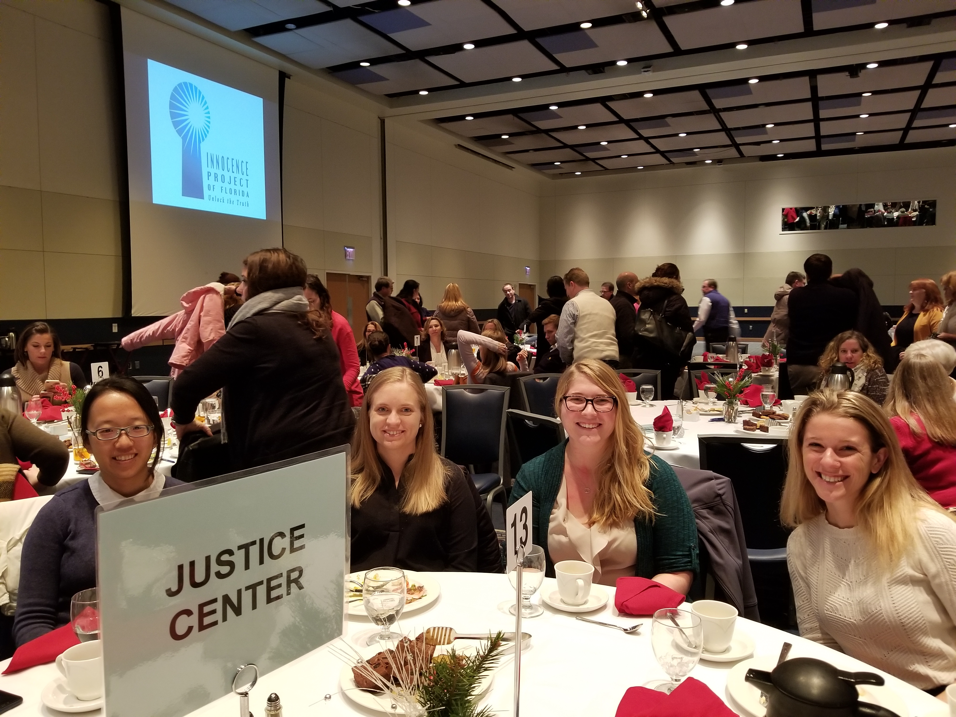

Graduate Students in the Criminology Program- Iris Lu, Kelsey Cundiff, Kim Davidson (Justice Center Graduate Student Assistant), and Rebecca Bucci

***CORRECTIONS AND RE-ENTRY***

# Justice Center Director Presents at the Gresham Sykes Memorial Workshop

Justice Center Director, Derek Kreager, presented “The Society of Female Captives: A Network Approach,” at the Gresham Sykes Memorial Workshop in Cambridge, UK in the fall semester.

# Inmate Society Research Review featured in *Penn State News*

Derek Kreager, Center Director, and Candace Kruttschnitt, University of Toronto and Center collaborator, discussed their recent paper "Inmate Society in the Era of Mass Incarceration" with [*Penn State News*](http://news.psu.edu/story/493441/2017/11/09/research/new-research-inmate-society-essential-prison-reform?utm_source=newswire&utm_medium=email&utm_term=493874_HTML&utm_content=11-13-2017-07-37&utm_campaign=liberal%20arts%20headlines%20issue). Their review of contemporary inmate social organization research, published in the Annual Review of Criminology, can be found [here](http://www.annualreviews.org/doi/abs/10.1146/annurev-criminol-032317-092513).

# Study on IQ Scores and Criminal Thinking in Criminal Justice and Behavior

An article titled, “Measuring the Criminal Mind: The Relationship Between Intelligence and CSS-M Results Among a Sample of Pennsylvania Prison Inmates” looks at the relationship between IQ and the measurement of criminal thinking. The article is featured in *Criminal Justice and Behavior*. The authors Michaela Soyer and Susan McNeeley are Justice Center Postdoctoral Scholar Alumni, now at Hunter College and Minnesota Department of Corrections, respectively, Gary Zajac is the Managing Director of the Justice Center for Research, and Bret Bucklen is the PADOC Research Director. The article is available [here](http://journals.sagepub.com/doi/pdf/10.1177/0093854817727318).

***SUBSTANCE ABUSE AND TREATMENT***

# Penn State Summit on the Opioid Epidemic

The Penn State Summit on the Opioid Epidemic took place on January 12th in the HUB-Robeson Center at University Park. The day included flash talks, discussion with feedback sessions, and a request for proposals. The Summit brought together almost 200 researchers, educators, and practitioners from across the Penn State system to foster conversations and promote collaboration and innovation on how to address the opioid crisis. Justice Center for Research Director, Derek Kreager, Ph.D., presented “*The Justice Center for Research: Mission and Opioid-Related Projects,*” and Justice Center Postdoctoral Scholar, Glenn Sterner, Ph.D., discussed “*A Comprehensive Criminological Research Agenda to Address the Opioid Crisis*.”

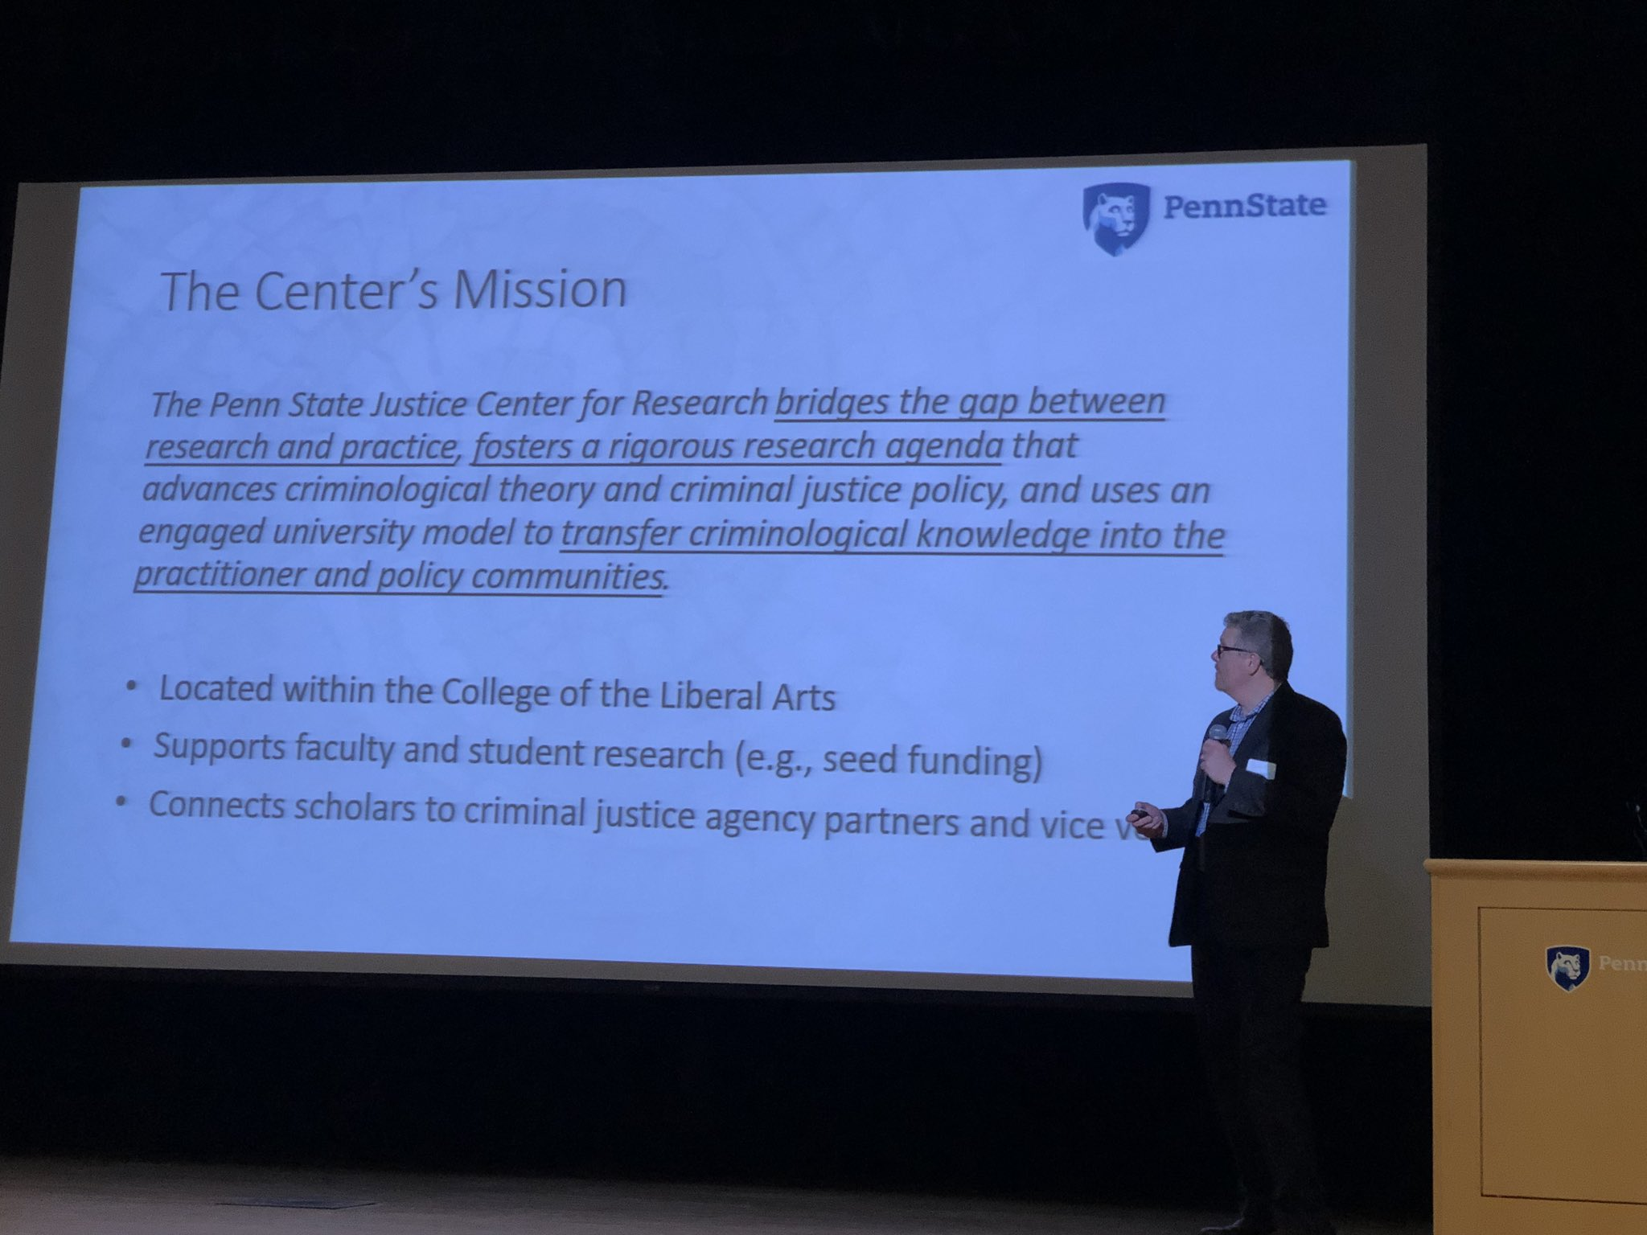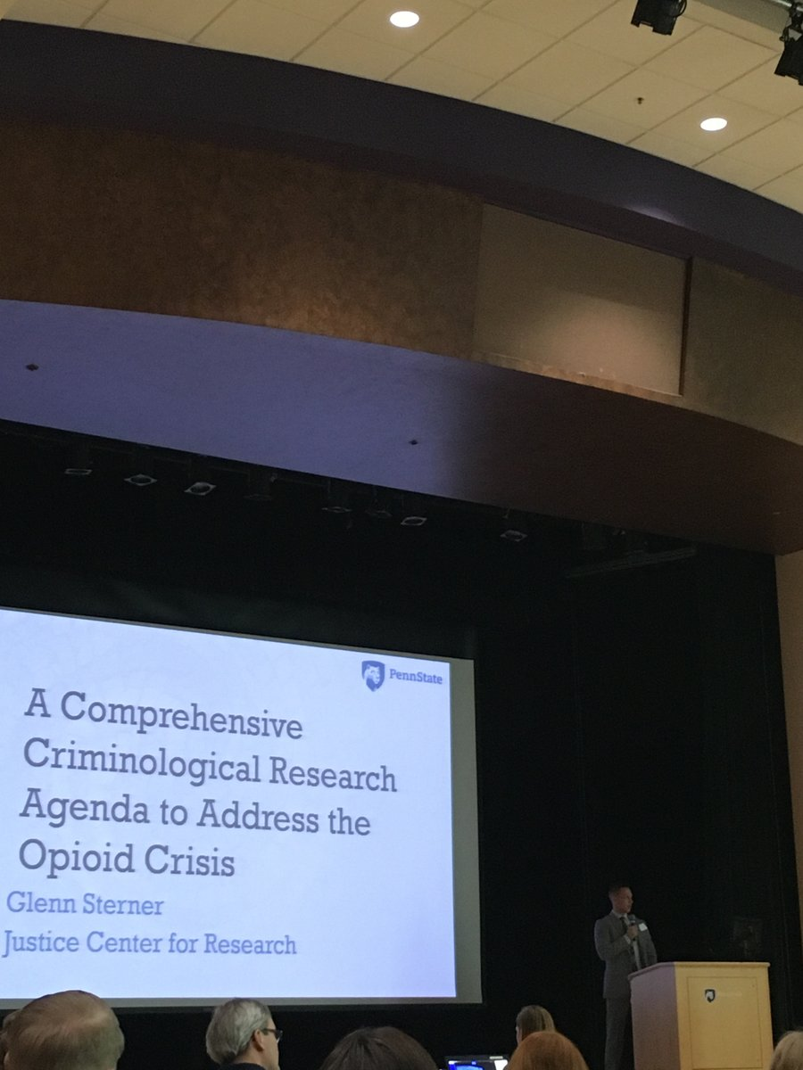

Derek Kreager, Center Director, and Glenn Sterner, Center Postdoctoral Scholar, presenting.

Wolf Administration to Support Project to Address Stigma Toward Opioid Addiction

Dr. Glenn Sterner, Justice Center Postdoctoral Scholar, has received an endorsement from the Pennsylvania Department of Drug and Alcohol Programs on his project with the Independence Blue Cross Foundation to address stigma toward opioid addiction. This project, named “Sharing Your Opioid Story” will collect stories of those who have been affected by the opioid crisis across multiple backgrounds and experiences, featuring them on an interactive website to raise awareness of the breadth and depth of the effects of opioid crisis in Pennsylvania. In addition, he will host community forums in the five-county Philadelphia region to raise awareness of stigma associated with opioid addiction in conjunction with the Independence Blue Cross Foundation, and work with the Foundation to develop a comprehensive campaign to address stigma. Initially the project focused on the Philadelphia region, but the Department of Drug and Alcohol Programs has agreed to work in partnership to highlight stories of the opioid crisis submitted by individuals from across the Commonwealth. Governor Tom Wolf announced this opportunity at an event hosted by Independence Blue Cross in December of 2017, featuring this initiative.

# Independence Blue Cross Foundation Grant Awarded

The Sharing Your Opioid Story project is a collaboration between the Independence Blue Cross Foundation, the Department of Drug and Alcohol Programs, and Penn State University. The team includes: Principal Investigator: Glenn Sterner (Justice Center for Research Postdoctoral Scholar); Co-Investigator: Gary Zajac (Justice Center for Research Managing Director); Researcher: Elaine Arsenault (Justice Center for Research Researcher). The project award was $111,723. Dr. Sterner was recently interviewed by Pittsburgh’s NPR News Station for the project. Listen here.<http://wesa.fm/post/campaign-seeks-fight-stigma-addiction-through-community-conversations#stream/0>

If you live in Bucks, Chester, Delaware, Montgomery, and Philadelphia counties and are interested in participating click the link below to learn more

<http://justicecenter.psu.edu/news/participate-in-the-share-your-opioid-story-project>

# Featured article on the opioid crisis by Justice Center Postdoctoral Scholar, in *Journal of Change*

A Special Edition of the *Journal of Change* on the opioid crisis, published by the Independence Blue Cross Foundation features an article by Glenn Sterner, Ph.D., Justice Center Postdoctoral Scholar. Dr. Sterner’s article “Seeing Past Stigma: 4 Ways to Confront Bias Toward Opioid Addiction” encourages individuals to consider the stereotypes surrounding opioid addiction and offers steps to alleviate the stigma associated with addiction. Dr. Sterner’s article can be found [here](http://mydigimag.rrd.com/publication/?m=40036&l=1&p=&pn=#%7B%22issue_id%22:437914,%22page%22:16%7D).

# Justice Center for Research Postdoctoral Scholar Glenn Sterner speaks to the Federal Reserve Bank of Philadelphia on the Opioid Crisis

Justice Center for Research’s Postdoctoral Scholar Glenn Sterner spoke to the Federal Reserve Bank of Philadelphia this past fall on his work on the Opioid Crisis. Invited by Keith Wardrip, Community Development Research Manager, Dr. Sterner led a conversation on his work in three projects across 16 counties in the State of Pennsylvania to catalyze an exchange on how the Community Development Studies and Education Department might develop opportunities to address the opioid crisis in their service region.

***ANNOUNCEMENTS***

# Advisory Board Meeting

The Justice Center Advisory Board Meeting was held on December 12. Justice Center personnel presented the Center initiatives and projects to a reconstituted board of agency partners, external and internal academics, alumni, and graduate and undergraduate leaders. The Advisory Board consists of the following members, Agency Partners: Secretary John Wetzel (Pennsylvania Department of Corrections), Bret Bucklen (Pennsylvania Department of Corrections  Research Director), Major Pat Brinkley (Pennsylvania State Police), Mark Bergstrom (Executive Director of the Pennsylvania Commission on Sentencing); PSU Representatives: Eric Baumer (Department Head of Sociology and Criminology), Susan McHale (Social Science Research Institute Director), Scott Bennett (College of the Liberal Arts Associate Dean for Research); Student Representatives: Corey Whichard (Justice Center for Research Graduate Assistant), Brittany Miraldi (Justice Association President); Alumni Representatives: John Kramer (Emeritus Professor of Sociology and Criminology); Michael Wagner (Admin Justice ‘95); Ricardo Nunez (Admin Justice ‘79) External Academics: Candace Kruttschnitt (University of Toronto, Professor of Sociology), Dana Haynie (The Ohio State University, Professor of Sociology, Director of Criminal Justice Research Center), Megan Kurlychek (University at Albany, SUNY, School of Criminal Justice, Associate Professor, Executive Director Hindelang Criminal Justice Research Center); Justice Center for Research Representatives: Derek Kreager (Justice Center for Research Director), Gary Zajac (Justice Center for Research Managing Director), Glenn Sterner (Justice Center for Research Postdoctoral Scholar).

# New Seed-Funded Projects

The beginning of Fall semester the Justice Center put out a call for proposals. The following are our new seed-funded projects.

**Courts and Sentencing**

*Illuminating the Opioid Drug Crisis in Pennsylvania: Trends, Patterns, and Correlates of Drug and Opioid Law Violations across Rural and Urban Pennsylvania Counties from 2000 to the present* – Drs. Darrell Steffensmeier and Jeffery Ulmer (Professors of Sociology and Criminology and Justice Center for Research Faculty Affiliates) will provide an assessment of the patterns and trends in opioid-drug law violations over the 2000-2017 period across a rural-continuum of counties in Pennsylvania as based on major markers of opioid abuse and/or social control responses to this abuse: arrests, convictions, imposition of intermediate punishments (e.g., treatment programs), and incarcerations.

**Substance Abuse and Treatment**

*Linking Accidental Overdoses to Medical Professionals and Pharmacies: A Population-Based Social Network Analysis* – Drs. Oren Gur (Assistant Professor of Criminal Justice, PSU Abington) and Glenn Sterner (Justice Center for Research Postdoctoral Scholar) will provide needed insight into the relationship between legitimate dispensations of prescription opioid painkillers via medical professionals and pharmacies, and fatal overdoses from opioids.

**Policy and Evaluation**

*Mechanisms of Firearm-Related Family Violence –* Dr. Amy Marshall (Associate Professor of Psychology) will build a foundation for a uniquely externally-valid examination of two alternative mechanisms by which firearms may contribute to violent behavior: psychological priming and threat reactivity.

*The Ethics of Policing –* Dr. Eduardo Mendieta (Professor of Philosophy, Associate Director of the Rock Ethics Institute) will provide an interdisciplinary and international conference on the ethics of policing that brings together political scientists, criminologists, philosophers, legal experts, and others. The Rock Ethics Institute will host this conference September 20-22, 2018, at PSU’s University Park Campus.

*Effects of Permanency on the Adult Criminality of Former Foster Care Youth –* Dr. Sarah Font (Assistant Professor of Sociology) will ascertain whether, and under what circumstances, adoption produces superior outcomes as compared with aging out of care among youth who enter the foster care system as adolescents.

# Justice Center Researchers Present at the Annual American Criminology Meeting in Philadelphia

Justice Center researchers presented at The American Society of Criminology meeting in Philadelphia November 15-18. The following presentations were given by researchers from the Justice Center for Research:

* + Inmate Expectations of Future Support and the Reality of Re-Entry: A Network Approach: **Corey Whichard**, PSU
  + Understanding Incarceration and Re-Entry Experiences of Female Inmates, Caregivers of Children, and Children: The Women’s Prison Inmate Networks Study (WO-PINS): Sara Wakefield, Rutgers University; **Derek Kreager**, PSU; Michaela Soyer, Hunter College; Dana Haynie, OSU; **Gary Zajac**, PSU
  + Are Changes in Pre-prison and Post-prison Social Networks Related to Increased Chances of Recidivism?: Hanneke Palmen, Leiden University; **Derek Kreager**, PSU; Sara Wakefield, Rutgers University; Anja Dirkzwager, Netherlands Institute for the Study of Crime and Law Enforcement; Paul Nieuwbeerta, Leiden University
  + Cognitive Transformation in a Prison-Based Therapeutic Community: **Kim Davidson**, PSU
  + First Person HOPE: Perspectives on the Honest Opportunity Probation with Enforcement Demonstration Field Experiment from HOPE Probationers and Team Members: Debbie Dawes, RTI International; **Gary Zajac**, PSU; **Elaine Arsenault**, PSU
  + The HOPE Implementation Experience in Four Sites: Lessons from the Honest Opportunity Probation with Enforcement Demonstration Field Experiment: **Gary Zajac**, PSU; Debbie Dawes, RTI International; **Elaine Arsenault**, PSU
  + Capital Punishment in Pennsylvania, 2000-2010: Seeking, Retracting, and Giving the Death Penalty: **Jeffery Ulmer**, PSU; **John Kramer**, PSU; **Gary Zajac**, PSU
  + Patterns of Income Generating Activities Among an Incarcerated Sample: Evidence from a Pilot Project: **Elaine Arsenault**, PSU; **Brandy Parker**, PSU; **Holly Nguyen**, PSU; **Gary Zajac**, PSU
  + Identifying and Informing Strategies for Disrupting Drug Distribution Networks: An Application of Community Policing to Local Opiate Markets in Pennsylvania: **Glenn Sterner**, PSU; **Ashton Verdery**, PSU; **Shannon Monnat**, Syracuse University, Maxwell School of Citizenship and Public Affairs; **Gary Zajac**, PSU, **Peter Forster**, PSU

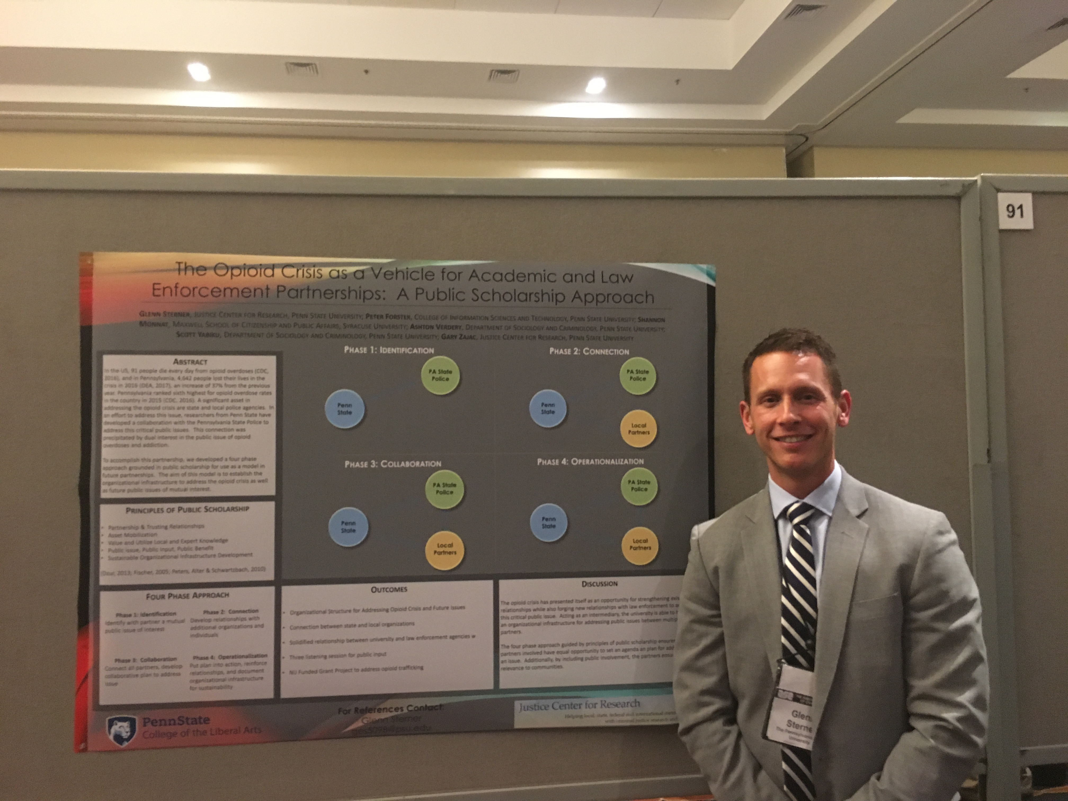

Justice Center Postdoctoral Scholar, Glenn Sterner, Ph.D. presenting at the Poster Session Thursday evening at ASC.

Center Director Named Liberal Arts Professor

Derek Kreager, Director of the Justice Center for Research, has been named a Liberal Arts Professor. Liberal Arts Professors are appointed by the Dean to recognize outstanding scholars and teachers in the College. It is an appointment reserved for those who have made substantial research contributions to their fields, served as excellent teachers, and provided significant leadership to the department, College, or university. Congrats Professor Kreager!

Justice Center Welcomes New Personnel

Sam Nur joined the Justice Research Center as a Research Technologist in November of 2017. Sam double majored and received his BA degrees in Criminal Justice, Law, & Society and Psychology & Social Behavior from the University of California, Irvine. While attending UCI, Sam studied effects of positive emotions on physiological function as research associate for the Stress, Emotion, and Physical Health Lab by running and recording participant data. Sam researched cannabis legalization policy under Dr. John Dombrink by collecting qualitative and quantitative data on cannabis dispensaries within the U.S as well as federal and state policy governing those dispensaries. Sam also taught an undergraduate class on 20th Century Terrorism, focusing on the psychological, political, and economic dynamics of the modern terror phenomenon. His research interests include drug policy, social networks, radicalization, and organized crime. Welcome to the Justice Center team Sam, we are excited to have you aboard!

Upcoming Talk

“Race and Rise of the Penal State: A Historical and Comparative Model” Loïc Wacquant, Ph.D., Professor of Sociology at University of California/Berkeley will present his lecture on March 30th at 2:00 p.m. in Foster Auditorium, Paterno Library.

Justice Center for Research

The Pennsylvania State University

304 Oswald Tower

University Park, PA 16802

814-867-3292

[www.justicecenter.la.psu.edu](http://www.justicecenter.la.psu.edu)

January 2018